ASSIGNMENT 1

CS5590 – WEB CLOUD MOBILE PROGRAMMING

By:

Adarsh Mergoju

16246333

Course Registration App

The application webpage allows students to enroll in courses of their choice according to their respective choices of Career choice, Semester and Education level. The students are prompted to login initially with their credentials and then make their selections.

1. Students are prompted to login initially.

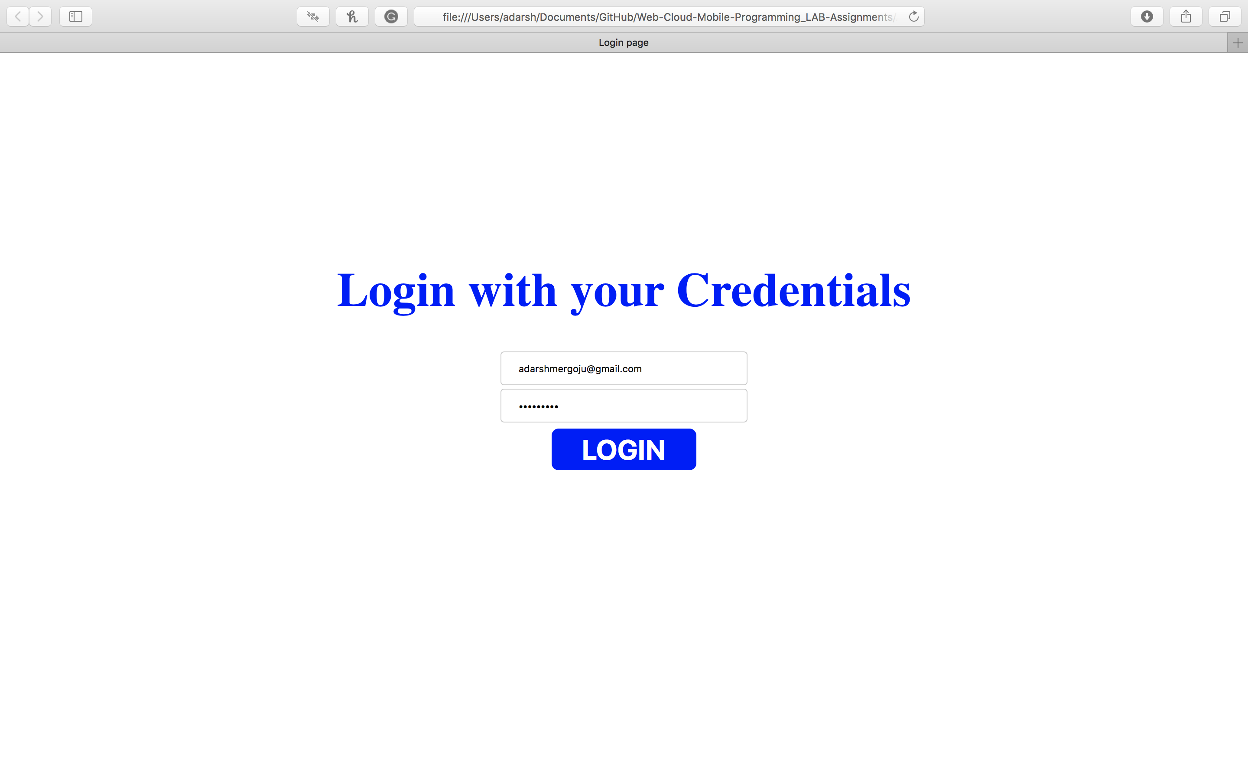

1. The students are then prompted to make their selections and then submit.

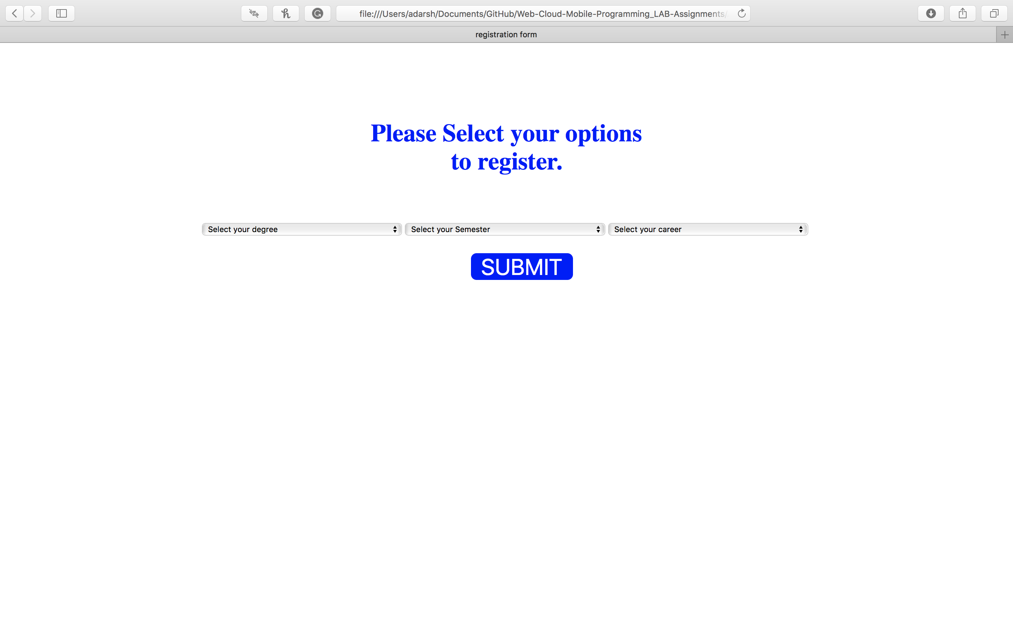

1. The Courses are then displayed after the selection has been made. The image below shows the courses available for the Dance course.

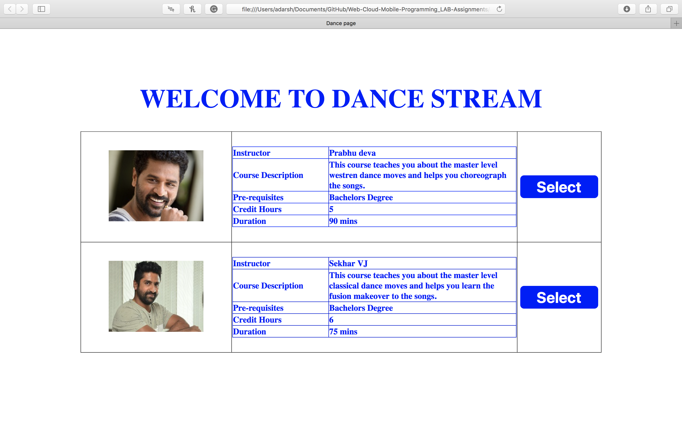

1. The Selected Course Details are then displayed after the selection has been made.

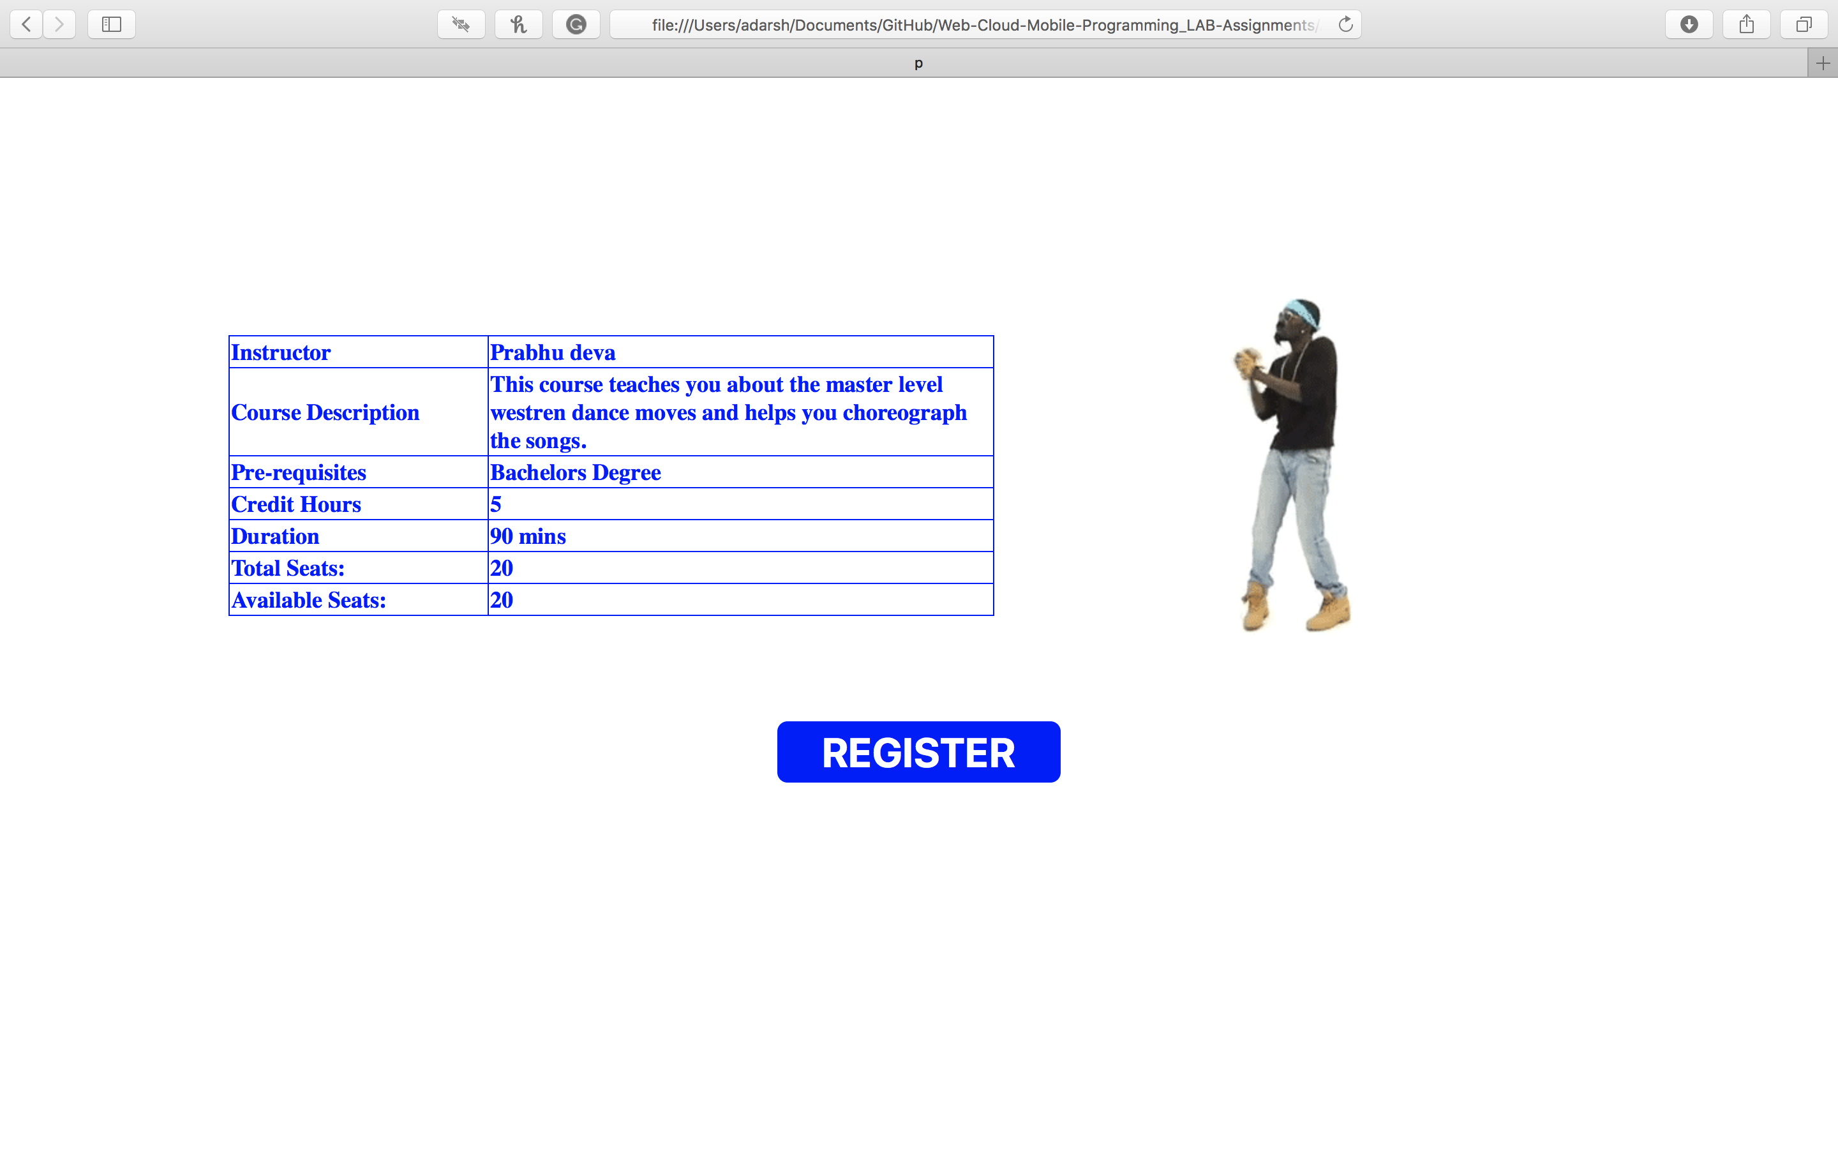

Finally, after registering by clicking the register button in the selected course. The Page redirects to the initial page to login again.

